
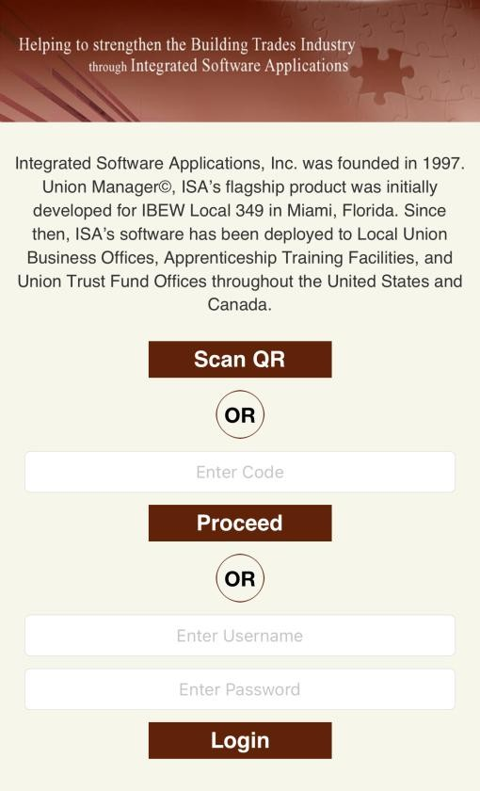
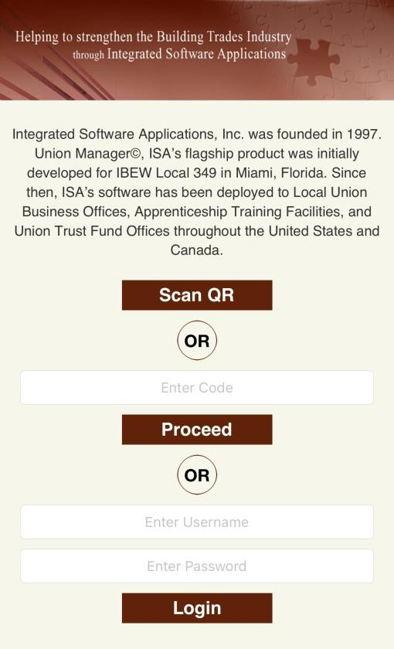

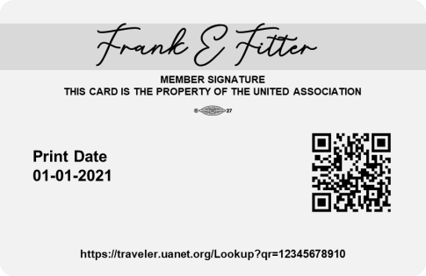
ISAQR MOBILE APP | DOWNLOAD & LOG IN
Vit

DOWNLOAD AND OPEN THE ISAQR APP FROM THE APPSTORE OR PLAYSTORE

OPT A:
SCAN UA MEMBER CARD
OPT B:
ENTER CREDENTIALS
1234567469
01012001
In the app, select
SCAN QR
and scan the
QR on the back of your UA member card.
OR
Enter your credentials and select
LOGIN
.
For most, the default credentials will be:
•
Username:

Your seven
-
digit UA card
number with 111 at the end
(
#######
111).
•
Password:

Last 4 of your SIN
-

