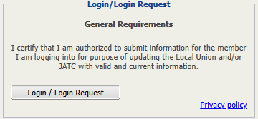
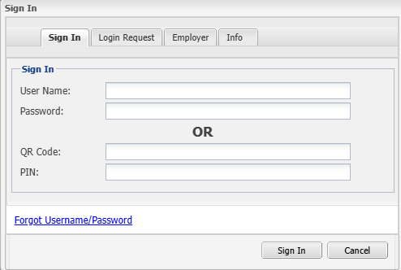
ISAWEB DESKTOP LOGIN

GO TO LOGIN PAGE
Type m.gotomyunion.com/?customerkey=142 into your internet browser or use the button below to open the login page.

ENTER YOUR CREDENTIALS
Enter your User Name and Password,
then select Sign In.

GO TO ISAWEB LOGIN PAGE

SELECT LOGIN / LOGIN REQUEST
On the home page, select the Login / Login Request button.
WHAT’S MY USERNAME/PASSWORD?

- Username: Your seven-digit UA card number with 111 at the end (example: 1234567111)
- Password: Last 4 of SSN

