User Guide – Online job selection

After you’ve logged in you will see the menu to the left with a new option.
You can click on View Open Jobs’ to view all open calls. If you want to request a call, click on Job Request
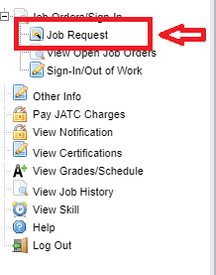

After you click on Job Request you will see this dialog box listing your current email address. PLEASE ENSURE THIS IS THE CORRECT INFORMATION PRIOR TO REQUESTING JOBS. If you wish to change your email or contact information click on ‘Change Profile’ and enter the appropriate information and click ‘Save’.

Click on Job Request to make sure your information is accurate. When it is, click OK to proceed.

Open calls will display.
You will now see a column titled Priority. In this column you will see a drop down menu for each job with a number next to the word Priority. Select the priority of the jobs you are interested in. Please ensure you flag each job in the order of your preference. This is the order the calls will be available to you if they are available.
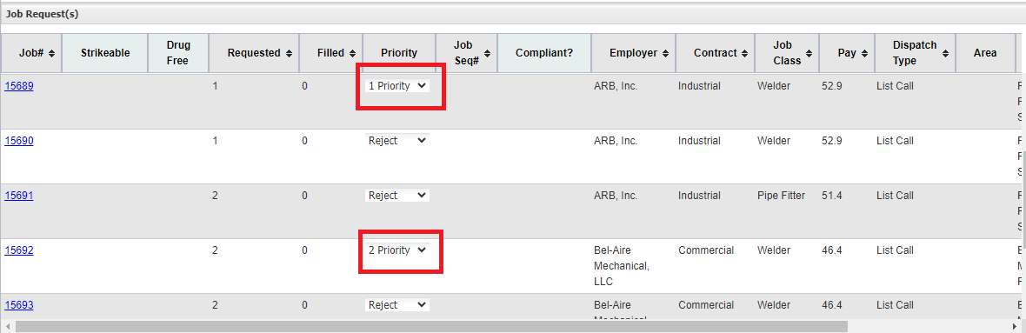

You can change the priorities at any time and if you decide you don’t want a call that you picked, you can change the choice to Reject.
Make sure to click on the blue job number to the left to see the requirements for the job. You will still need to meet the qualiﬁcations for the job (certs, experience, etc.) in order to be dispatched.
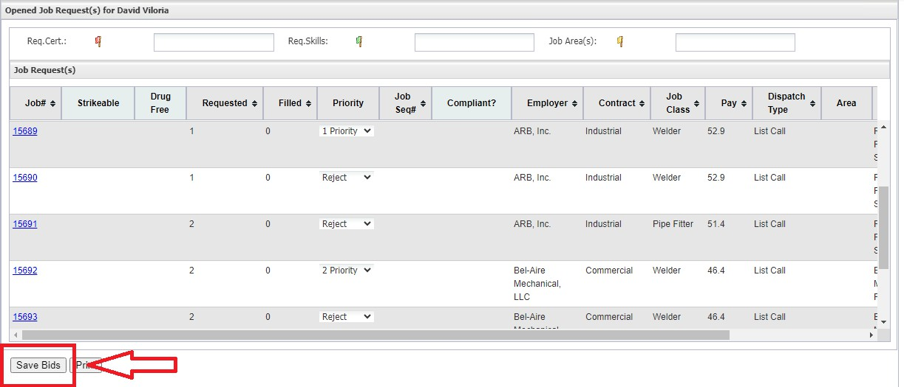
When you have ﬁnished picking the job(s) that you interested in, click the Save Bids button on the bottom of the screen.

After you click Save Bids you will see this dialog box if you left jobs as Rejected. This is perfectly normal so click Yes and you are all done.
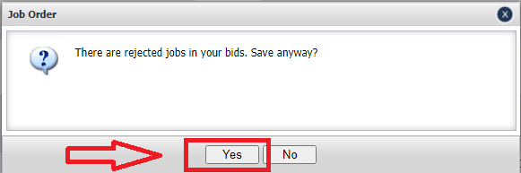

Some things to remember:
- The job selection option will open up at 5:00 pm every evening, Monday – Friday.
- You can change your selections as many times as you want as long as you click on Save Bids after each change.
- At 8:00 am the following morning, the program will run and assign you to a work call based on your position on the out of work list and the priority that you assigned to the call.
- After everything has been assigned and veriﬁed the dispatch will be emailed to the email address on ﬁle.

